JDeveloper JSP Development Best Practices: Thick Databases Illustrated

The process of building a scalable and maintainable web application has many tradeoffs to consider. No single approach can handle all of the possible situations. However, after a few years of implementing small, medium and large web applications, several best practices have emerged.

The most important of these is to move as much code as possible into the database. This is a difficult transition for most experienced application programmers to make. Historically, applications have been built with tools that coded a great deal of complexity into the client-end. This approach embraces an architecture that views the database as nothing more than a set of tables to hold information. The complex set of rules for modifying data would be entirely handled by the client application. Now, with browser-based, internet applications this approach is no longer appropriate. The current thinking is based around the phrase “thin-client,” which can be leveraged to the point that nearly all data collection, validation, navigation, and error handling is performed in the database.

Consider building a simple application that attempts to update a single record. During the update process, the client code would only capture and submit the information the user wishes to update. The remainder of the validation and logic for correctly applying the updates would be handled with code in the database. If the database validation fails, a custom error message is sent back with information that will direct the client to re-display the update record page. If the validation succeeds, the database directs the client code to a Success Page as shown in Figure 1.
Welcome
Page
PageOne
(update record)
Success
Page

Figure 1: Data update and validation path

The majority of the work required to build this simple web application will be in the creation of the appropriate database objects. When the database is complete, the remaining work is equally divided between the middle tier (ADF BC) objects, Struts diagram, and page layout.
For this training session, you will do the following:
- Analyze a set of business rules to display information for a given employee.
- Update the manager to whom the employee reports by selecting one of the managers in the list-of-values (LOV).

The completed application will look something like Figure 2.

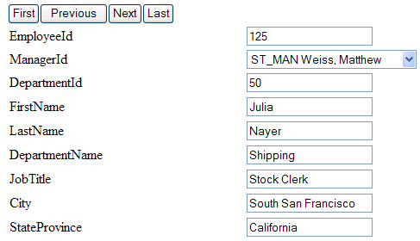

Figure 2: Sample Employee/Manager Application

I. Exploring the Human Resource (HR) schema
The application you will build will be based on Oracle’s sample HR schema, plus a few additions.
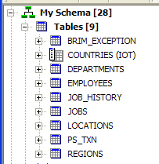
The HR schema tables shown in Figure 3 have been created to store simple business organizational information. The schema has implemented a number of hierarchical relationships between the objects stored in these tables using traditional database constraints.
You can examine the REGIONS table shown in Figure 4 by selecting Tools/SQL Worksheet and typing in the statement shown in Figure 4.

Figure 3: HR Schema Tables

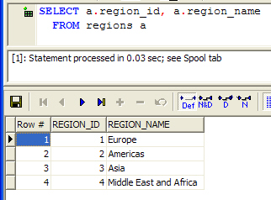
Figure 4: HR Schema Regions Table

The COUNTRIES table shown in Figure 5 is a child of the REGIONS table. Notice the Foreign Key (FK) column for the parent table on the right (REGION_ID).

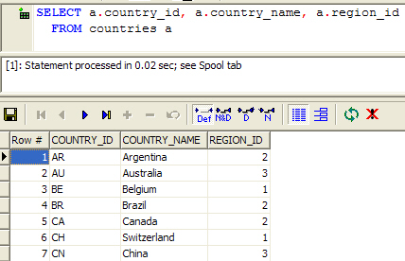
Figure 5: HR Schema Countries Table

Going to the next levels, the LOCATIONS, DEPARTMENTS and EMPLOYEES tables are shown in Figures 6, 7 and 8.
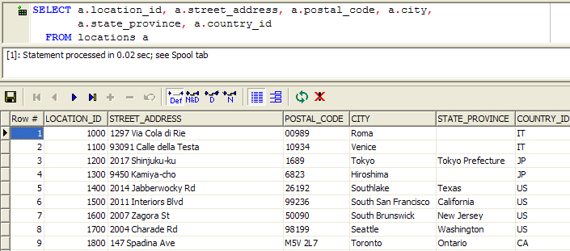

Figure 6: HR Schema Locations Table

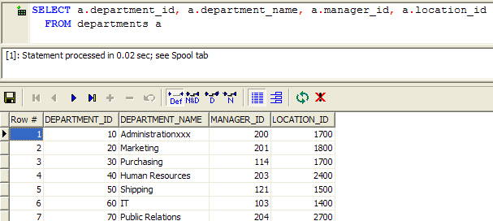
Figure 7: HR Schema Departments Table

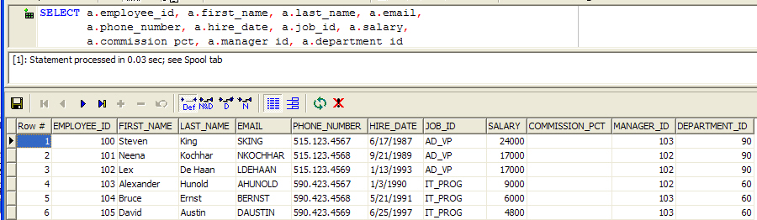

Figure 8: HR Schema Employees Table

Another hierarchical relationship has the JOBS table at the top as shown in Figure 9.

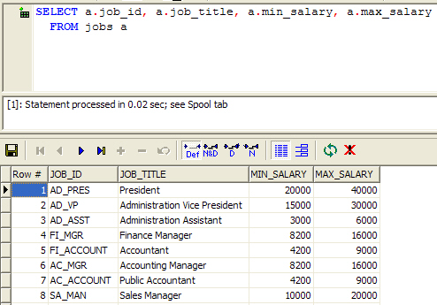

Figure 9: HR Schema Jobs Table

Since employees can have many jobs, and the same job title may be held by many employees, you will need an intersection table to capture the many-to-many relationship between EMPLOYEES and JOBS. Thus a JOB_HISTORY table was added as shown in Figure 10.

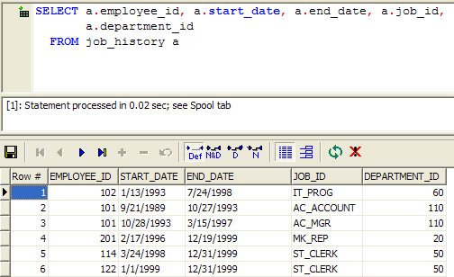
Figure 10: HR Schema Job History Table

Looking a little deeper at the actual data in these tables, you may discover a few surprises. Try the following: Collect the Manager IDs that are currently assigned in the EMPLOYEES table as shown in Figure 11.
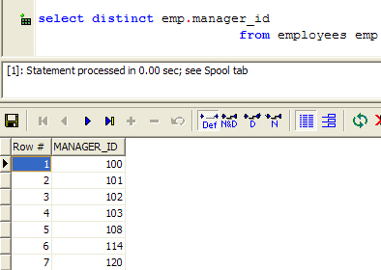

Figure 11: Manager IDs

Next add JOB_ID LASTNAME, and FIRSTNAME to your query. You will discover that the employee with EMPLOYEE_ID = 103 is an IT_PROG (Programmer) acting as a manager because his EMPLOYEE_ID is listed in the MANAGER_ID column as shown in Figure 12.

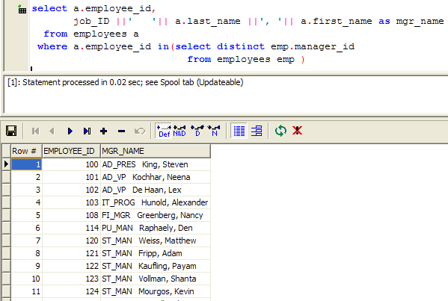

Figure 12: Manager Names

Look the Shipping Dept (Dept 50) shown in Figure 13. It has 5 managers! All of the managers in this department report directly to the President, but only one (121) is listed in the DEPARTMENTS table (shown in Figure 7).

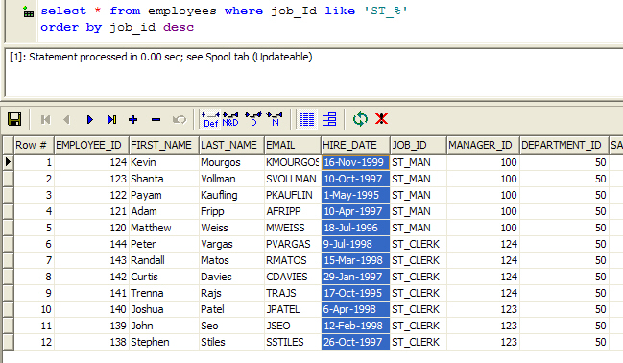
Figure 13: Data in the HR Schema

The following are the business rules for changing the manager to whom an employee reports:
- An organization that allows for multiple managers in each department (or no manager at all)
- Employees may report to any of the managers within the department. (Employees who are acting as Managers, report to a manager in another department)
- Only the President may have a null manager_id.
- Employees may be managed by a non-manager.

When building your business logic to support updating an employee’s manager, you will need to take these business rules into account. Also, additional database objects will be needed to give the end user appropriate feedback when they select an inappropriate manager.

The following exercises will guide you through the process of implementing the business rules above using the HR Schema.
II. Building the application

A. Database
The following items needed to be added to the database in order to support the proposed architecture of housing all of the validation and complex logic to update a single column in the database.

Implement a database View with a multi-table join that represents “Page One” in the application. (Just use the EMP_DETAILS_VIEW from the HR schema)
- Create an INSTEAD OF trigger on the database view, to update the underlying table.
- Create a database table to hold custom error messages.
- Create a database package to hold package variables that store the current error.
- Create a database one-row view to expose custom error messages.
- Create a JUNK table for debugging.
- Create a Sequence Counter to populate ORDER_NR in the JUNK table.
- Create an autonomous_transaction Procedure to populate the JUNK table.

1. Create an INSTEAD OF Trigger
INSTEAD-OF Trigger on “PageOne” View (Emp_Details_View)

CREATE OR REPLACE TRIGGER t_iu_emp_details_view
INSTEAD OF
UPDATE
ON emp_details_view
REFERENCING NEW AS NEW OLD AS OLD
declare
current_exception_Id number;
old_mgr_job_Id varchar2(10);
new_mgr_Job_id varchar2(10);

--cursor to get custom error message
cursor current_Exception_info(cin_current_exception_Id NUMBER) is
select exception_CD from brim_exception
where exception_id = cin_current_exception_Id;
current_exception_CD_Row current_Exception_info%ROWTYPE;

--cursor to get job_id for old manager
cursor old_manager_Info is
select job_Id from employees
where employee_id = :old.manager_id;
old_job_id_Row old_manager_Info%ROWTYPE;

--cursor to get job_id for new manager
cursor new_manager_Info is
select job_Id from employees
where employee_id = :new.manager_id;
new_job_id_Row new_manager_Info%ROWTYPE;

--Now check for updates,
--then apply logic to either update, or throw error messages
Begin
if updating ('manager_id') then
--Capture Debug Information
--p_junkauton('employee_id= '||:old.employee_id||
-- ', oldmanager_id= '||:old.manager_id||
-- ', newmanager_id= '|| :new.manager_id);

--check rules
--get job_id for old manager
open old_manager_Info;
fetch old_manager_Info into old_job_id_Row;
close old_manager_Info;

--get job_id for new manger
open new_manager_Info;
fetch new_manager_Info into new_job_id_Row;
close new_manager_Info;

--first rule: special case of Deceased managerId =176
if :new.manager_id = 176 then --managerId =176 Taylor, Jonathon
current_exception_Id := 20;--Error: This manager is deceased

--else test: if old manager job_id is different from new manager job_id
elsif nvl(nvl(old_job_id_Row.job_Id,new_job_id_Row.job_Id),'zasdfg') =
nvl(nvl(new_job_id_Row.job_Id, old_job_id_Row.job_Id) ,'zasdfg') then
--if same no error
current_exception_Id := -1;
else -- if different create error message
--Error: the manager you have selected is in a different area.
current_exception_Id := 10;

end if;

--Check current_exception_Id for error (not equal to -1)
if ( current_exception_Id != -1) then
--cursor to get custom error message
open current_Exception_info(current_exception_Id);
fetch current_Exception_info into current_exception_CD_Row;
close current_Exception_info;

--Capture Debug Information
--p_junkauton('current_exception_Id= '||current_exception_Id||
-- ', current_exception_CD_Row.exception_CD= '||
-- current_exception_CD_Row.exception_CD );

-- now update package variables that brim_error_view is based
dml_error.setmessage(10, current_exception_CD_Row.exception_CD);

else
-- no rules broken proceed with update
update employees set manager_id = :new.manager_id
where employee_id = :old.employee_id;

--clear any error message
dml_error.clearmessage;
end if;
end if;
end;

2. Create a database table to hold custom error messages when validation fails

CREATE TABLE brim_exception
(exception_id NUMBER NOT NULL,
exception_cd VARCHAR2(200) NOT NULL,
descr_tx VARCHAR2(2000))
/

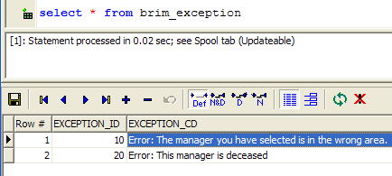

3. Create a database package to hold package variables that store the current error

CREATE OR REPLACE
PACKAGE dml_error is
--****************************************************--
--this package handles all brim exceptions
--*****************************************************--

-- Package Variables to store the current error message
Id Number;
Message Varchar2(2000);

-- procedures to set and clear the package variables
procedure SetMessage(NewId Number, NewMessage varchar2);
procedure ClearMessage;

-- functions to get the current error message
function GetId return Number;
function GetMessage return Varchar2;

end;
/

CREATE OR REPLACE
PACKAGE BODY dml_error
IS
--****************************************************--
-- Purpose: provide get/set procedures/functions to access package variables
--****************************************************--
function GetId return Number is
begin
return Id;
end;

function GetMessage return varchar2 is
begin
return Message;
end;

procedure ClearMessage is
begin
Message:=null;
id:=null;
end;

PROCEDURE SetMessage
( NewId IN Number,
NewMessage IN varchar2)
IS
BEGIN
Id :=NewId;
Message := NewMessage;
EXCEPTION
WHEN OTHERS THEN
null ;
END;
END;
/
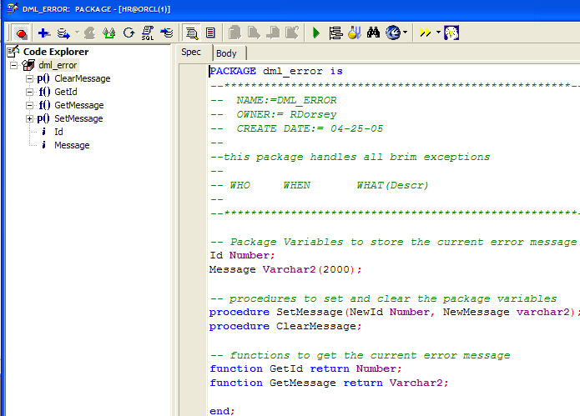

4. Create a database one-row view to expose custom error messages.

create or replace view brim_error_view (
code,
message )
AS
select dml_error.getid Id, dml_error.getmessage Message
from dual
/

5. Create a JUNK table for debugging purposes:
-- sequence counter for JUNK

CREATE SEQUENCE junk_seq
INCREMENT BY 1
START WITH 101
MINVALUE 1
MAXVALUE 999999999999999999999999999
NOCYCLE
ORDER
CACHE 20
/

-- create table for JUNK

CREATE TABLE junk
(junk VARCHAR2(4000),
creat_dt DATE DEFAULT sysdate,
order_nr NUMBER DEFAULT 0

)
/

-- Triggers for JUNK

CREATE OR REPLACE TRIGGER ui_junk
BEFORE
INSERT
ON junk
REFERENCING NEW AS NEW OLD AS OLD
FOR EACH ROW
begin
select junk_seq.nextval
into :new.order_nr
from dual;
end;

An autonomous_transaction Procedure to populate the JUNK table:
CREATE OR REPLACE
PROCEDURE p_junkauton
(in_tx varchar) is
PRAGMA AUTONOMOUS_TRANSACTION;
begin
insert into junk (junk) values(in_tx);
commit;

END; -- Procedure
/

NOTE: You can now add the P_junkauton() procedure in any of your database PL/SQL. This allows you to capture debug data even if an exception is thrown, due to the autonomous_transaction and associated inner commit. The sequence counter populating the order_nr guaranties that you can put P_junkauton() in several places and still tell which piece of code executes first.

The following code could be included in the trigger used above as an aid to debugging.
--Capture Debug Information
p_junkauton('employee_id= '||:old.employee_id||
', oldmanager_id= '||:old.manager_id||
', newmanager_id= '|| :new.manager_id);

This screenshot shows an example of the debugging information that would be placed in the Junk table to view old and new values.

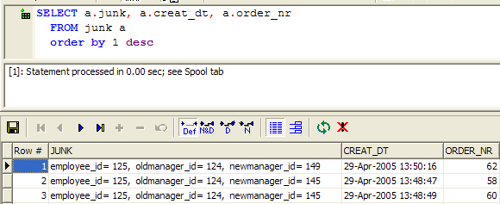

II. Working with JDeveloper Middle Tier - ADF BC
The following is a summary of steps that you will use to explore JDeveloper and build a simple web application module. Each step is explained in more detail with screen shots showing what you should see as you complete each one.

- Create a database connection (Username: dulcian Password: oracle).
- Create a new Application Workspace based on the Web Application (default) template.
- Build ADF BC View objects to handle read-only data:
- Custom error messages (BrimErrorView)
- List-Of-Values (LOV) to update a given field on “PageOne” (MgrLOVView)
- Build ADF BC entity and view objects to handle read/write data:
- Point to the custom database View for “PageOne” (PageOneEmpDetailsView)
- Build ADF BC ApplicationModule to:
- Expose ADF BC Views to the client. (AppModule)
- Expose custom java code in the AppModuleImpl.java to the client. (getBrimErrorMessage)

A. Create a database connection
  - Select the Connections tab of the Navigator. If it is not visible, select View | Connection Navigator from the menu.
  - Right-click the Database node and select New Database Connection. If the Create Database Connection - Welcome page appears, click Next.
  - On the Type page of the Create Database Connection wizard, enter “dulcian” for the Connection Name. Leave the Connection Type on the default setting - Oracle (JDBC). Click Next.
  - On the Authentication page, enter “dulcian” as the Username and “oracle” as the password. Leave the Role field blank. Check the Deploy Password checkbox as shown in Figure 14. Click Next.
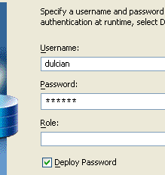

Figure 14: Connection Manager Authentication page
  - On the Connection page, leave the default settings (thin, localhost, 1521, ORCL) and click Next.
  - On the Test page, click the Test Connection button. A “Success!” message should appear in the Status window. Click Finish. You will see the new connection listed in the Navigator. If it doesn’t, go back and check the previous steps.

B. Build an application workspace based on the Web Application Template
- Click the Applications tab in the Navigator. If it is not visible, select View | Application Navigator from the menu.
- Right-click the Applications node and select New Application Workspace.
- Fill in the Application Name as shown in Figure 15 and select Web Application [Default] from the Application Template pulldown. Click OK.
NOTE: The Application Template contains default projects that are oriented toward a certain technology such as Struts. The template affects what options and objects are available by default for use in the projects. Almost all of the lists in 10g are context-sensitive, so inappropriate options are rarely available.

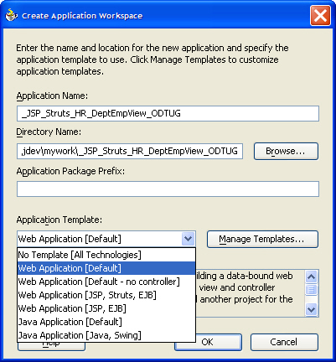

Figure 15: Create Application Workspace dialog

You will now see the _JSP_Struts_HR_DeptEmpView_ODTUG workspace in the Applications Navigator along with the Model and ViewController nodes created as part of the Web Application template.
NOTE: Some items are shown in italics. This means that they have not been built (compiled). When you click either the Make or Rebuild icons on the toolbar, the italics will disappear. This is a handy way to tell when something in JDeveloper has been changed since any “unbuilt” items will show in italics.

C. Build ADF BC View objects to handle read-only data
The next step is to create the view objects needed for this simple application. There are two basic ways to build ADF BC View Objects that are intended for read-only data. One way is designed to build the query automatically when it can be based on a database table or view. The second way presents an empty text box where you must enter the desired code.

1. Create Business Components
The first step is to create the business components needed for the application.
- To create the appropriate view objects, right click the Model node in the Applications - Navigator and select New.

- In the New Gallery, select the Business Components category (under Business Tier) and Business Components from Tables from the Items list as shown in Figure 16. Click OK.
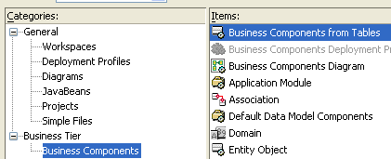

Figure 16: New Gallery

- When the Business Components Project Initialization dialog appears, make sure that the new database connection (dulcian) you created earlier appears in the pulldown. Leave the other settings and click OK.

- The Create Business Components Welcome page will appear. Click Next.

- On Step 1, of the Wizard, Entity Objects from Tables, uncheck the Tables checkbox and check the Views checkbox to see the available views. You will see BRIM_ERROR_VIEW and EMP_DETAILS_VIEW.

- Select EMP_DETAILS_VIEW and click the right arrow to move it to the selected column. Use the Entity Name field to change the Entity Name to “PageOneEmpDetailsView.” Click Next.

- On the Updateable View Objects from Entity Objects page, select PageOneEmpDetailsView and click the right arrow to move it to the selected window. Click Next.

- On the Read-Only View Objects from Tables page, uncheck the Tables checkbox and check the Views checkbox as shown in Figure 17. Select BRIM_ERROR_VIEW and click the right arrow to move it to the Selected window. Note that JDeveloper adds an additional “View” suffix to the name. In the View Name Field, delete the extra “View” as shown in Figure 17. Click Next.

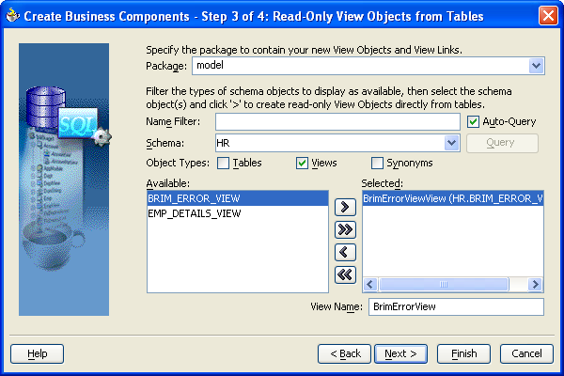
Figure 17: Selecting Read-Only View Objects

- On the Application Module page, leave the default settings and click Next. Since this is the first time you used the Business Components from Tables wizard, you are able to create and populate the Application Module. Later you will clean up the code that is generated, and add the rest of the objects needed for the user interface code.

- You can review your selections on the Finish page and go Back if needed. Otherwise, click Finish. You will see the additions in the Navigator which should look like Figure 18. Click the Rebuild button to compile the code.

NOTE: By default, JDeveloper may name the AppModule view object instances with a trailing number such as 1, 2, 3...etc. as shown in the Structure pane in Figure 18. This is not helpful or useful. It is recommended that you delete these extra instances and rename them appropriately to avoid confusion. You will do this in Section V of this tutorial.
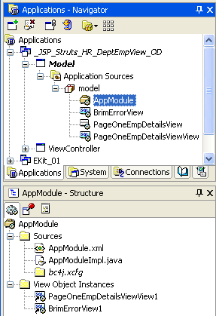

Figure 18: Application Navigator/Structure pane

- Double click BrimErrorView in the Navigator to open the View Object Editor. Select the Java node. Under ViewRow Class: BrimErrorViewRowImpl, check the Generate Java file checkbox. Click Apply and OK.

2. Create a New View Object
The next step is to create a new view object to support the manager LOV.

- Right-click the top level Model node in the Applications Navigator and select New. Select the Business Components category and the View Object item. Click OK.

- Click Next if the Welcome page of the Create View Object Wizard appears. Leave the default package name and enter “MgrLOVView” for the Name. Ensure that the “Rows Populated by a SQL Query with” radio button is selected. Select the Read-only Access radio button and click Next.

- On the Query page of the Create View Object wizard, manually add the following query in the Query Statement window:
select null as employee_id, null as mgr_name from dual
union all
select a.employee_id, job_ID ||' '||
a.last_name ||', '||a.first_name as mgr_name
from employees a
where a.employee_id in(
select 176 as manager_id from dual
union all
select distinct emp.manager_id
from employees emp)

- It is a good idea to click the Test button to test your code. You should receive a “Query is valid” message. Click OK, then click Next.

- Review the information on the Attribute Mappings page and click Next.

- Click Next on the Attributes page.

- On the Attribute Settings page, verify that EmployeeId shows in the Select Attribute pulldown. Ensure that the Queriable checkbox is checked. Check the Selected in Query checkbox and the Employee ID must also have the Key Attribute checkbox checked as shown in Figure 19.

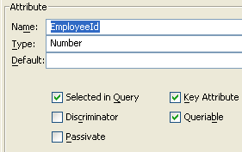
Figure 19: Attribute Settings

- Use the Select Attribute pulldown to select the MgrName attribute. Ensure that the Queriable checkbox is checked and check the “Selected in Query” checkbox. You do not need to select the Key Attribute checkbox for this attribute. Click Next and Finish to complete the wizard.

- Click the Rebuild icon on the toolbar to compile the project. Make sure that the Messages window shows a successful compilation.

- If desired, you can use the query above in the JDeveloper SQL Worksheet (Tools | SQL Worksheet) to retrieve the Manager Names for each Employee ID in the HR database as shown in Figure 20.

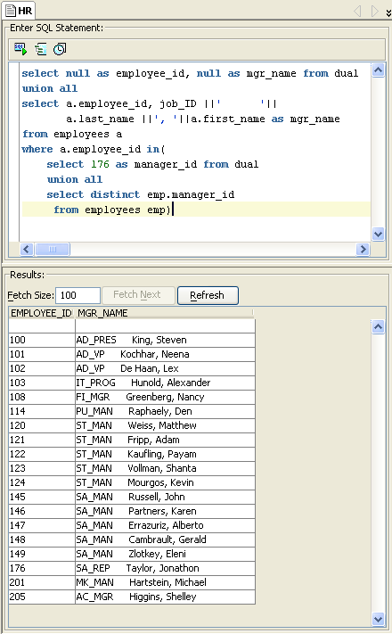
Figure 20: Retrieving Manager Names

IV. Remove extra columns from PageOneEmpDetailsView to pass only data needed for PageOne and remove generated RowID

- Double click PageOneEmpDetailsViewView to open the View Object Editor. Click the Attributes node (not the plus sign). In the Selected pane, hold down the Ctrl key and highlight the following unnecessary attributes: JobId, LocationId, CountryId, Salary, CommissionPct, CountryName, and RegionName. Click the left arrow to move these out of the Selected pane. Click Apply and OK.

- Double click PageOneEmpDetailsView to open the View Object Editor. Click the Attributes node (not the plus sign). In the Entity Attributes pane, hold down the Ctrl key and highlight the following unnecessary attributes: JobId, LocationId, CountryId, Salary, CommissionPct, CountryName, RegionName and click the Remove button. Click Apply. You should now have the following entity attributes: EmployeeId, ManagerId, DepartmentId, FirstName, LastName, DepartmentName, JobTitle, City, StateProvince and RowID.

- If not already expanded, click the plus sign next to the Attributes node. Click the EmployeeId attribute. Check the Primary Key checkbox. Ensure that the Persistent, and Mandatory and Queriable checkboxes are also checked as shown in Figure 21. Click Apply.

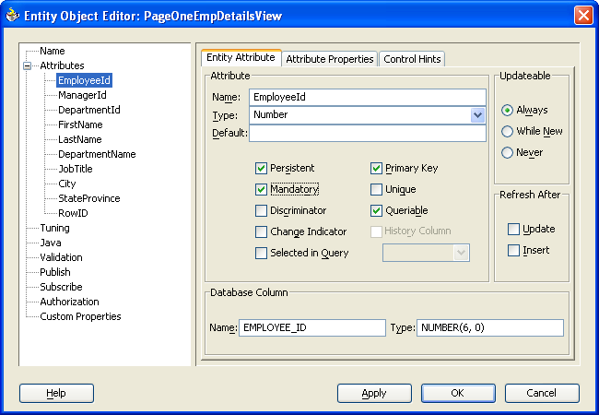
Figure 21: Entity Object Editor

- Select RowID from the Attributes List and uncheck the Primary Key checkbox to allow you to delete it. Click Apply and OK.

- Double click PageOneEmpDetailsViewView in the Navigator. Click the RowID attribute in the Selected column and click the left arrow to remove it. Click Apply and OK.

- Double click PageOneEmpDetailsView in the Navigator. Select the RowID attribute and click the Remove button. Click Apply and OK.

- Click the Rebuild icon in the toolbar to compile the project.

V. Updating the ADF BC Application Module
- Double click AppModule in the Navigator to access the Application Module Editor.

- Move all of the items from the Data Model side out of the pane one at a time using the left arrow.

- Using the right arrow and the Name and Instance Name fields, move and rename the View Objects so that the Application Module Editor Data Model window (right side) looks like Figure 22. You can either rename the object in the Available View Objects side before moving it to the Data Model side or rename the Instance after it is moved to the Data Model side. Click Apply after each name change to save it.

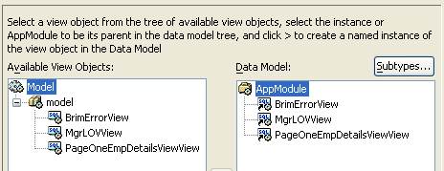

Figure 22: Application Module Editor

- Click OK. The Structure pane should look like Figure 23. Click Rebuild to compile the project.

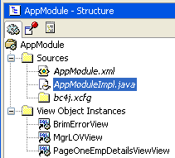
Figure 23: AppModule Structure pane

- In the AppModule - Structure pane, double click AppModuleImpl.java to access the code editor.
NOTE: AppModuleImpl.java file is where you add custom Java code. This file works with the ADF data bindings to provide you with drag & drop access for your custom code.

- To add the following code (methods) at the top of the AppModuleImpl.java file just below the class declaration: public class AppModuleImpl extends ApplicationModuleImpl, click after the curly bracket and press Enter to add a new line. Paste or type in the following code:

public String getBrimErrorMessage()
{
//send data down to the database
this.getTransaction().postChanges();

this.getBrimErrorView().executeQuery();
if( this.getBrimErrorView().first()!=null &&
((BrimErrorViewRowImpl)this.getBrimErrorView().first()).getMessage()!=null &&
(((BrimErrorViewRowImpl)this.getBrimErrorView().first()).getMessage()).length()>0)
{

//refresh clean data from database
int currentRowIndex = this.getPageOneEmpDetailsViewView().getCurrentRowIndex();
this.getPageOneEmpDetailsViewView().executeQuery();
this.getPageOneEmpDetailsViewView().setCurrentRowAtRangeIndex(currentRowIndex);
this.getTransaction().commit();

return "isError";
}
return "success";
}

public void setPageOneToEmp125()
{
this.getPageOneEmpDetailsViewView().executeQuery();
this.getPageOneEmpDetailsViewView().setCurrentRowAtRangeIndex(25);
}

- Click the Rebuild icon to compile the code.
NOTE: If there are errors when you compile the code, they are likely due to a problem with the view names. Check to make sure that the view names in the Navigator match the names in the code.

- Double click AppModule in the Navigator to access the Application Module Editor. Expose the custom methods by clicking the Client Interface node and moving both of the available methods into the Selected panel using the double arrows. Click Apply and OK.

- Click the Rebuild icon and make sure that the project compiles with no errors. Close the AppModuleImpl.java window by clicking the X on the tab.

III. Build the JSP Struts Client
Now you are ready to create the JSP/Struts portion of your application.

A. Create the Struts Page Flow Diagram
- Right-click the View Controller node in the Navigator and select Open Struts Page Flow Diagram. The Component Palette or the Data Control Palette will be displayed on the right side of the screen and the blank diagram will be in the center.

- If necessary, click the Components tab to display the Struts Page Flow components. Drag an Action component from the Component Palette on to the struts-config.xml diagram.

- Click the name (grey area) and rename it “/startHere”. Press Enter.

- Add a “Welcome” page by dragging the Page icon on to the diagram. Click in the gray area to rename the page “/welcomePage.jsp”. Press Enter.

- Add a Data Page and rename it “pageOneDP”. Press Enter. This page actually consists of the components shown in Figure 24.

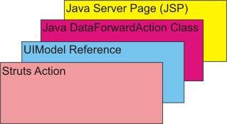
Figure 24: Data Page components

- Add another Page and rename it “/successPage.jsp”. Arrange the diagram as shown in Figure 25.

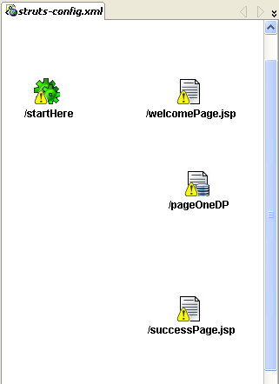
Figure 25: struts-config.xml diagram

- Double click each of the components to create them. Click OK on the Create dialog for the /startHere Data Action. You will then see the code file in the main window. An additional tab will be added to the work area. Click the X in the right corner of the tab header to return to the struts-config.xml diagram. Double click on each of the pages. The pages will open as a blank page each time. Click the X in the right corner of the page tab to close it. Click Yes on the Save Files dialog for each of the pages. The exclamation points will disappear.

1. Add Navigation and custom logic
Use the following steps to add the page navigation and logic to the application.
- Click Page Link in the Component Palette. Then click the welcomePage and pageOneDP to connect them as shown here:
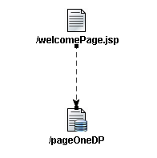
NOTE: If needed, you can right click on the line and select Straighten Lines to clean up the diagram.

- Expand the ViewController, Application Sources, and view nodes in the Applications - Navigator. Double click the ApplicationResources.properties node to view ApplicationResources.properties for the Link’s displayed text:
Change “link.pageOneDP=link to /pageOneDP.do” to “Go to Page 1.” Close the window by clicking the X on the ApplicationResources.properties tab. Click Yes on the Save Files dialog.

- On the struts-config.xml diagram, add a Page-Link from the Success page back to PageOne as shown here.
NOTE: You can create nodes in the lines you draw by simply clicking and changing directions as you draw.
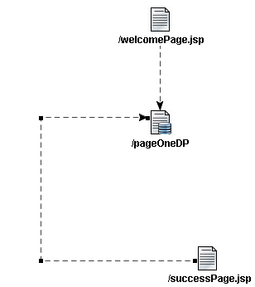
- Add a DataAction and place it as shown in Figure 26. Rename it /getBrimError. Press Enter

- Add a Forward from pageOneDP to getBrimError. Double click the “success” word and rename the Forward “Submit”. Press Enter.

- Add a Forward from getBrimError to pageOneDP, rename to “isError”. Press Enter.

- Add a Forward from getBrimError to successPage.jsp, leave name as “success” Your diagram should look something like Figure 26.

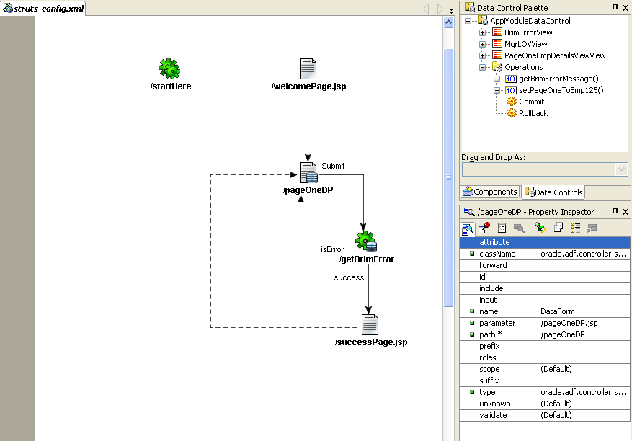

Figure 26: Dragging & Dropping from the Data Control Palette

- Switch from the Component Palette to the Data Control Palette using the Data Controls tab under the palette area. Expand the AppModuleDataControl node and the Operations node. Drag & drop getBrimErrorMessage( ) from the Data Control Palette on top of the /getBrimError data action on the struts-config.xml diagram. You will not see any change in the diagram but you will see additions in the Navigator.

- Double-click /getBrimError to open the Create Struts Data Action dialog. Click OK to create the getBrimErrorAction class.

- When the GetBrimErrorAction.java tab opens, add the following code in between the curly brackets:
protected void findForward(DataActionContext actionContext) throws Exception
{
HttpServletRequest request = actionContext.getHttpServletRequest();
if(request.getAttribute("methodResult")!=null && ((String)request.getAttribute("methodResult")).length()>0)
{
actionContext.setActionForward(actionContext.getActionMapping().findForward((String)request.getAttribute("methodResult")));
}
super.findForward(actionContext);
}

- The DataActionContext in the code will be underlined in blue. Place the cursor anywhere on the blue line and click. Press Alt-Enter to make the required imports. You will need to do this twice. Close the GetBrimErrorAction.java file by clicking the X on the tab. Select Yes on the Save Files dialog.

- Click the Components Tab to return to the Components Palette and add a DataAction between the startHere dataAction and the welcomePage as shown in Figure 27.

- In order to set the model for the page correctly, draw a Forward from /dataAction1 to /pageOneDP. Press the delete key to delete this forward.

- Add a Forward from startHere to dataAction1

- Add a forward from dataAction1 to the welcomePage. The diagram should now look like Figure 27.

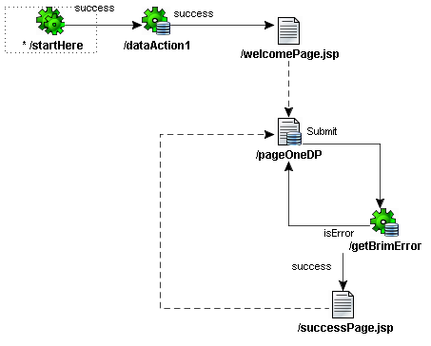
Figure 27: struts-config.xml Diagram

- Click the Data Controls tab. If needed, expand the AppModuleDataControl and Operations nodes. Drag and drop the setPageOneToEmp125( ) operation onto the /dataAction1 component in the struts-config.xml diagram. You will not see any change in the diagram.

- Click the Rebuild icon to compile the project.

2. Edit the JavaServer Page
You can now edit the Java Server Page you created.

- Double click /welcomePage.jsp to edit the Welcome page. Click under the link.pageOneDP marker, press Enter and type “Welcome”. If desired, you can use the pulldowns and other text edit buttons to change the look of the text. For this practice, select Heading 1 from the first pulldown. Note the font change.

- Click the struts-config.xml tab. Double click successPage.jsp, click under the message link.pageOneDP, press Enter and type “Success!” If desired, you can use the pulldowns and other text edit buttons to change the look of the text. For this practice, drag over the word and click the B to make the text bold.

- Close both of the JSP pages by clicking the X on each tab. Answer Yes to the Save Files dialog for both.

3. Edit pageOneDP

- Double click pageOneDP to open the blank page. From the Data Control Palette, if needed, expand the AppModuleDataControl and select PageOneEmpDetailsViewView. Select Input Form from the Drag and Drop As pulldown. Drag and drop the PageOneEmpDetailsViewView onto /pageOneDP.jsp as an InputForm. You will see something like this:
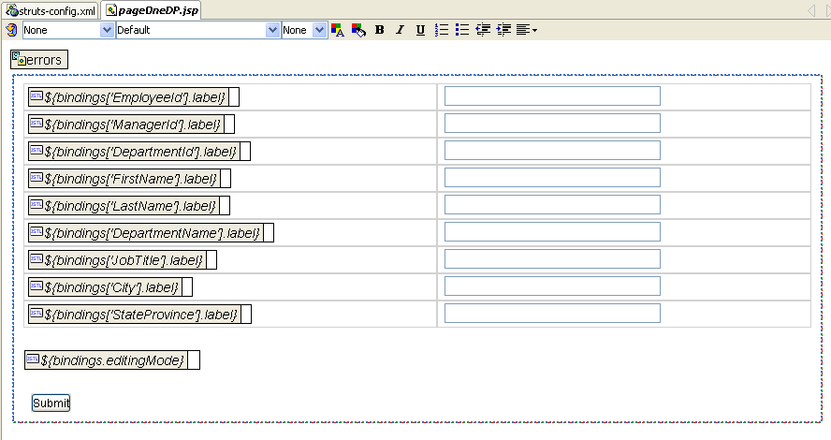
- Add Navigation buttons by selecting PageOneEmpDetailsViewView in the Data Control Palette again and Drag and Drop as Navigation Buttons under the Submit button. Be sure to drop the navigation buttons inside of the red dotted line.

- In the Structure pane, click the second tab (UI Model). Click the PageOneEmpDetailsViewViewIterator node and change the Range Size to -1 in the Property Inspector. Click Enter.

3. Construct the ManagerID LOV

- In preparation of making the ManagerID an LOV it is necessary to delete the ManagerID Input Field from the JSP page. Select the field next to the {$bindings[‘ManagerID’].label} in the pageOneDP.jsp and press the Delete key. The page should look like this:
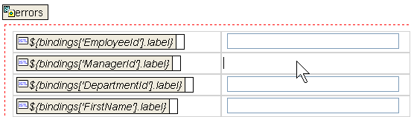
- You must also delete ManagerId from the pageOneDPUIModel.xml. Click the UI Model tab in the structure pane. Right click the ManagerId node and select Delete. Click Yes on the Delete:ManagerId confirmation dialog.
NOTE: This is a very import step to remember. Any time you remove a databound object from a JSP page, you must also remove it by hand from the appropriate UIModel file.
- Expand the PageOneEmpDetailsViewView node in the Data Control Palette. Select ManagerID and Drag and Drop As List of Values into the blank cell next to ${bindings[‘ManagerId’] label}. A drop down arrow will appear as shown in Figure 28.
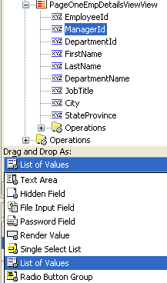
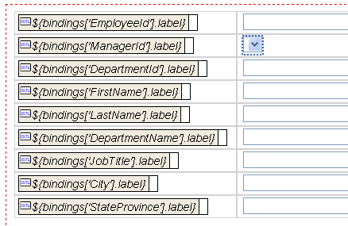
Figure 28: Adding a List of Values (LOV)

4. Edit the ManagerId with the List Binding Editor
- In the Structure pane, select the UI Model node and double click ManagerId to open the List Binding Editor.

- On the LOV (Source) Data Collection side, expand the AppModuleDataControl node. Select MgrLOVView and click the newly activated New button. Click OK on the Iterator Id dialog. The new iterator will appear in the Structure pane.

- Select PageOneEmpDetailsViewView in the Target Data Collection pane and Click Add. Change the Target Attributes pulldown to Manager Id as shown in Figure 29.

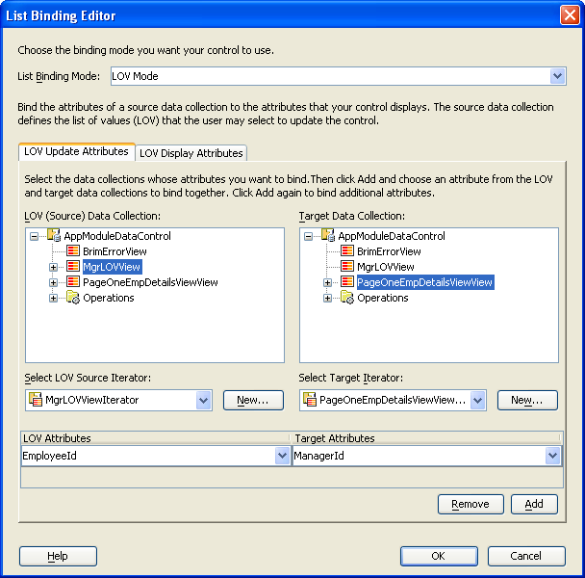

Figure 29: List Binding Editor
- Still in the List Binding Editor, switch to the LOV Display Attributes tab and move MgrName from the Available Attributes pane to the Attributes to Display pane using the right arrow. Click OK.

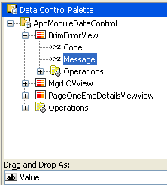
- On the Data Control Palette, expand the BrimErrorView node. In order to add error feedback to pageOneDP, drag and drop Message as a Value just above EmployeeId. As shown in Figure 30.
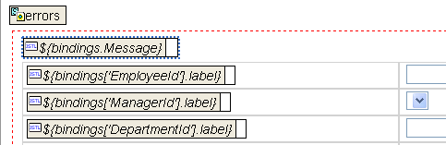

Figure 30: Adding error feedback message

- Change the bindings.Message color to red by selecting it and clicking the color text Icon (the one with the A).

- Close the pageOneDP.jsp window by selecting the tab and clicking the X. Answer Yes on the Save Files dialog.

- Select the UI Model tab in the structure pane. Select the MgrLOVViewIterator node and change the Range Size to -1 in the Property Inspector. Press Enter.

- Click the Rebuild icon to compile the application. Make sure there are no errors showing in the Messages window.

IV. Test the Application
You are now ready to test the application.

- In the struts-config.xml diagram, right click startHere and select Run. The Embedded OC4J Server will start and the messages window will display the progress.

- The default browser will open to display the Welcome page with a link to the pageOneDP.do. Click the link to display the page shown in Figure 31.
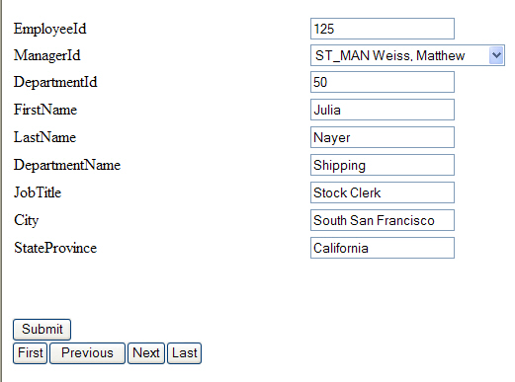

Figure 31: Completed JSP page

- Test the application by clicking the First and Last buttons. You can also view the list of Employees using the pulldown.

- Test the error page by selecting a manager from a different department and click the Submit button.

